Journal 29-2 page 5-7

The Vagus Nerve & Its Role in Manifesting Love

by Claudia Rose

Early in my Esoteric Healing practice in rural Vermont I realized that the issues affecting the majority of my clients were nervous system related. After exploring a variety of ways to calm and sooth the nervous system, I eventually found that work relating to the vagus nerve best brought the sympathetic and parasympathetic systems into balance and released constriction in the shock triangle.

The vagus nerve is the 10th cranial nerve and comprises 90% of the Parasympathetic Nervous System fibres. It arises from the midbrain and brings calm to the organs of the body from the lateral aspect of the hemispheres of the brain and the larynx to the digestive organs of the lower abdomen allowing them to function more effectively. The origins of the vagus nerve are in the midbrain of the brain stem.

See diagram overleaf.

Distributing Soul Energy

The vagus nerve is also vitally important as the major directing agent of Soul energy. DK, says: “For the average disciple, before there is complete soul control and monadic direction, the major directing agent, via the brain, is the vagus nerve, along which the energies (entering via the head centre) are distributed to the rest of the body.” Esoteric Healing, p.122

In other words the vagus nerve is the primary link between spirit and matter for the majority of us at this time. It distributes the love and consciousness energy of soul through our bodies via our organs.

To become better acquainted with the route of this most important nerve through your body, I invite you to feel into your body as I take you on a journey through it.

The Journal of the INEH 5

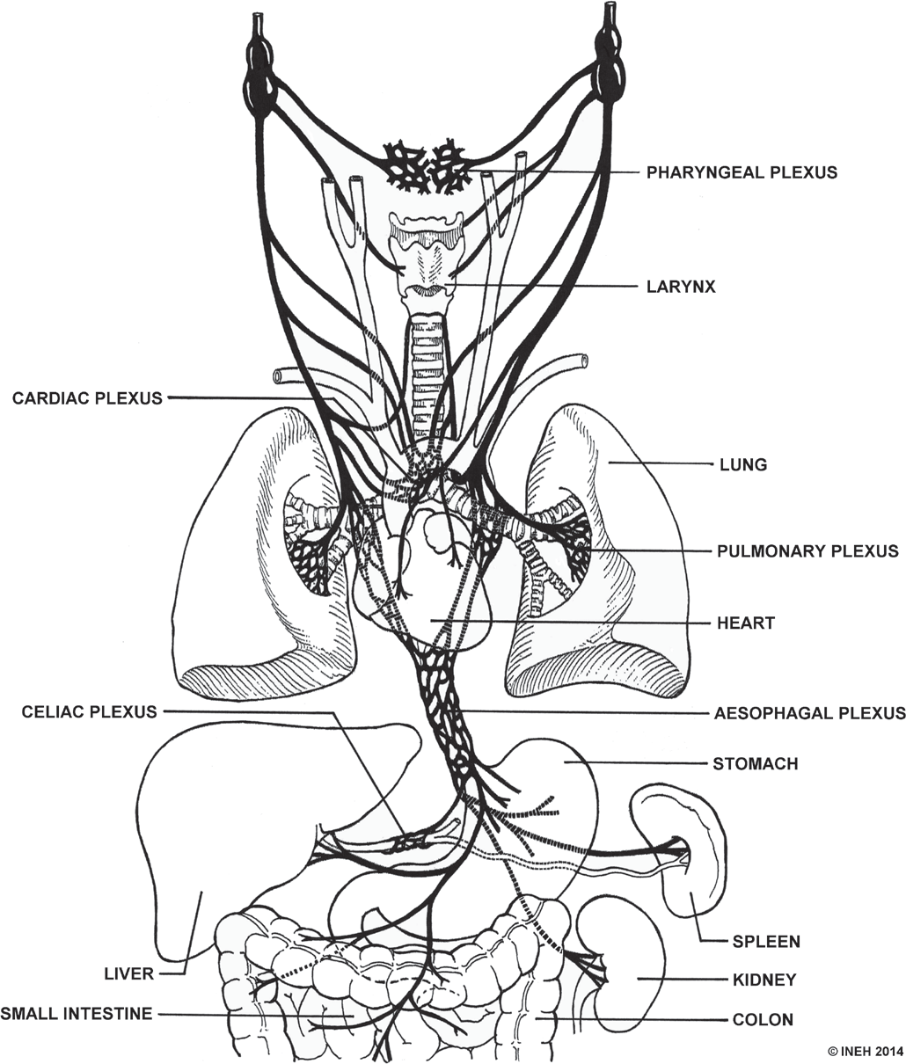
Vagus nerve distribution.


I suggest that you begin by aligning and attuning as if you were going to work on yourself. Then feeling love and appreciation for your vagus nerve hold the intention to allow your vagus to be moved to a new level of continuity and relaxation.

- Take some deep breaths feeling our bodies relax more deeply with each out breath.
- Think ‘brain stem’ and feel into your brain stem at the top of your spine at the level of your ears and hold it in an attitude of love and appreciation. This may feel like pressure at the top of your throat.
- Continuing to hold an attitude of love ask your left and right vagus nuclei in the back of the brain stem to light up so you can feel where they are.
- Now feel the nerves leave the brain stem and continue down either side of your neck to the top of your sternum where there is a network of nerves called a plexus. Feel the energy of the plexus that is the location of your vagus nerve minor. From there feel this etheric love energy going into the middle of each lung and sending its relaxing energy throughout the lungs and bronchi. Feel the energy going to your heart organ bringing relaxation.
- Then also sense this calming energy flowing to the kidneys on either side of the spine at the bottom of the rib cage behind the stomach.
- Now feel the vagus nerve energy moving along the oesophagus down through the diaphragm to the plexus below the solar plexus that we call the minor below the solar plexus. From here gently follow the energy of relaxation as it moves to the liver on the right, the stomach and spleen on the left, and the pancreas below the stomach.
- Feel energy flow into your small intestine in the middle of your belly and into your colon remembering the web of vagus energy that relaxes your digestive tract and allows your food to be digested and eliminated.
- Now returning to the brain stem, feel the energy from the vagus nuclei flow now to larynx and the lateral aspects of the hemispheres around the ears.
- Pause and feel your whole body. Can you feel the relaxation that loving focus on the vagus can bring to your organs and musculature? Let us acknowledge this as the light of our soul moving through us. We can bring this light to our clients according to the will of the soul.

Take Control

We know that the vagus functions without voluntary control. Recent research is showing us, however, that we are not the victims of our Sympathetic Nervous System When we become conscious that our thoughts are taking us deeper into a state of alert, Stephen W Porges in The Polyvagal Theory and others suggest:

- Taking some deep breaths with a focus on the exhale (the inhale takes us more into Sympathetic while the exhale moves us more into the Parasympathetic Nervous System)
- Do some yoga
- Go for a walk in nature
- Sing a joyful or calming song
- Take a nap
- Meditate using a Loving Kindness meditation

These actions allow our vagus to reactivate and balance the sympathetic response. Scientists have actually been able to quantify the impact that we can have on our own vagus nerve. Perhaps knowing that scientific proof exists will inspire you and your clients to take action to open to the support of your Soul through your vagus nerve.

Vagal Tone

We each have our own natural degree of vagal tone which has an impact on our health, mental focus, ability to recover from stressful situations and feelings of social connectedness.

While 65% of our vagal tone seems to be in our genetic make up, a research project showed that volunteers who reported the most positive emotions daily during the nine-week study had higher vagal tone. The more each volunteer focused on positive emotions and feeling of social connectedness the more likely she was to experience an improvement in vagal tone.

So we too can positively impact our vagal tone and consequent health by maintaining an attitude of positive emotions and feelings of social connectedness. Perhaps science is beginning to prove that energy follows thought!

6 The Journal of the INEH

Below is a practical that I frequently use with clients experiencing stress. A full flowing vagus nerve calms our nervous system and facilitates the flow of the love of our soul energy through our bodies.

SUGGESTED VAGUS NERVE PRACTICAL

- Align, attune and allow
- Balance the Ajna and the 5 centres on the body
- Balance:
SP + spleen BC + adrenals SP + liver BC + kidneys
BC + spine
- Alta Major Routine
  - Heart Centre + point above the HC/
- Vagus Nerve minor
  - Solar Plexus + minor below the SP
  - Balance the Alta Major
- Balance the Shock Triangle:
Point below the Solar Plexus + ileocecal valve point + sigmoid flexure point
- Alta Major balance from the back
  - AM + cerebellum
  - AM + the Fourth Ventricle
  - AM + the carotid gland in the etheric
  - AM + the vagus nuclei in the medulla oblongata (brainstem)
- Flow vagus nerve from the nuclei to the Vagus Nerve plexi one side at a time.
  - Holding the AM with one hand use the other hand plus the Ajna to gently allow the energy of the vagus nerve to flow from the left nuclei to the vagus nerve minor above the Heart Centre. Then continue through the diaphragm to the minor below the SP.
  - Continue to hold the AM with the same hand and trace the energy of the right Vagus nuclei to the vagus nerve minor above the Heart Centre. Then continue through the diaphragm to the minor below the SP
* If you find an area that is not flowing easily, stop and hold that area inviting energy to flow according to the will of the soul.
- Return to the Alta Major Routine and Shock Triangle
Recheck triangles
- Close

