INTERNATIONAL NETWORK FOR ENERGY HEALING
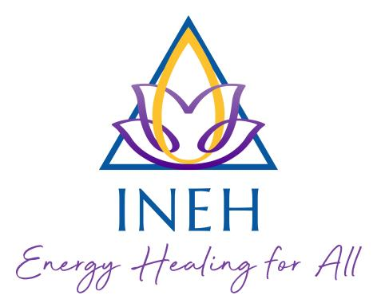

APPLICATION FOR 2026 MEMBERSHIP OR RENEWAL (AND DETAILS UPDATE)

NAME
ADDRESS + POST CODE + COUNTRY
TELEPHONE
EMAIL
WEBSITE (if applicable)
DATE OF BIRTH
OCCUPATION / OTHER THERAPIES OFFERED
HIGHEST INEH COURSE LEVEL STUDIED (ie Parts 1, 2, 3, 4)

DATE COMPLETED COURSE & TEACHER
HAVE YOU COMPLETED INEH ASSESSMENT AND CERTIFICATION?  IF SO, WHEN? | YES/NO  DATE:
DO YOU REQUIRE PUBLIC LIABILITY INSURANCE (for practicing healing facilitators only)

Please note that the renewal of your insurance will be given on the understanding that:
- You have never been convicted of or charged (but not yet tried) with any criminal offence, other than motoring offences or offences that are spent under the Rehabilitation of Offenders Act 1974, nor do you have any prosecutions pending.
- You have never had a proposal or renewal for Healing insurance declined or cancelled; a policy voided, withdrawn or suspended or special terms imposed by any insurer.
- You have never had any claims, or incidents, which could give rise to a claim under the policy involving negligence, error or omission, or are you aware of any circumstances which may cause such a claim or suit being made against you?
- You, or any partner or director of your business, have not been the subject of or have proceedings or applications pending for any winding-up order, receivership, debt relief, liquidation, administration, county court judgement, company or individual voluntary arrangement, bankruptcy or insolvency.

By paying the membership renewal, your cover will be conditional on above conditions being satisfied. If you cannot satisfy any of the above conditions, please contact us so we can refer to insurers for their further consideration.

HEALING PRACTITIONER LISTING  (FOR QUALIFIED PRACTITIONERS ONLY) | YES / NO  (please write in box below)
May we list your name, email and geographical region on the website?

Would you be happy to accept referrals?

May we share your contact details with other members?

Do you give your permission for the INEH to keep your information on a computer database for INEH purposes only?
(This request is a Data Protection Act requirement)

Which geographical region are you located? | Region:

FEES AND PAYMENT METHODS  Members £35, Student Members £35, Couple/families £50, Friends £20 | YES/NO  (please write in box below) | AMOUNT £ (please write in box below)
I have made a Bank Transfer (see below)

I have made a PayPal payment (see below)

I have made an additional donation

TOTAL PAYMENT:

INEH BACS and Standing Order details are:

The Co-op bank, Sort Code 08-90-81, Account No 65021532
Account Name I.N.E.H. (UK) R/C 1032492.

For PayPal, follow this link INEH PayPal, then select ‘Send’ and follow the on-screen instructions. Please include an extra £1 to cover the PayPal transaction fees. You may also use the PayPal Donate button from our website.

Thank you
Ian Yearwood, Membership Secretary
Email: membership@INEH.org.uk
Mob: +44 (0)781 0626 397

