Journal 23-1, page 3-8
The Life Stream and Occult Healing
Don Nichol, conference 2007, life thread, sutratma

Please note that all material here is taken or derived from the Bailey books - primarily from Esoteric Healing, p. 580 to p. 683. In many cases the quotes have been altered in places to make them easier to understand.

The first law of healing states: “All disease is the result of inhibited soul life.” So, we must begin by asking, what is life? Fortunately, D.K. addresses this question in A Treatise on White Magic.

“We have the terms of SPIRIT, LIFE & ENERGY. The word Spirit is applied to that essentially undefinable insight also called life – that rhythmic inflow of vital energy that manifests as Soul or consciousness. What is it? Who can say? We can trace it back from physical life to the soul or consciousness aspect and from soul to spirit. We seek to express it in words and end by calling it Spirit, the One Life, the Monad, or Energy. TWM/23 But these concepts are so far removed from ordinary thinking humanity that it is of little value to enlarge upon it further.”

D.K. also states: “It is of prime importance for students of the occult to think of Life in terms of Energy. Spirit and Energy are in fact synonymous terms and are interchangeable. Only in this realization can we arrive at a true understanding of the world of active phenomena which surrounds us and in which we move.”

“It can be said that this mysterious Life principle is that in man that holds together, vitalizes and drives its form into activity. In the human experience, it is by means of a stream or thread of life energy called the sutratma that this life principle is able to manifest and the means by which vitality and communication can occur between Monad, soul and its human manifestation. The sutratma or silver thread incarnates from the beginning of the period of manifestation stringing upon itself the pearls of human existence. It is the line of energy that connects the personality of man with his father in Heaven via the soul. Upon it are found those focal points of energy we call the permanent atoms.”

The purpose and will of the soul, its purpose to be and to do, utilizes the sutratma as its means of expression in form. It is a direct stream of purposeful life flowing from soul to personality. When it reaches the body, this life current differentiates into countless threads and forms that complex interweaving we call the etheric body. Upon this energized, etheric scaffolding, atoms of material substance gather to form the many cellular structures of the physical body. These are then held and maintained in their functioning forms by the attractive will of the soul.
It is important to understand that the sutratma is composed of two energies that the soul embodies and transmits to its personality. These two aspects extend from the soul as a single blended stream of energy and then divide into two streams after entering into the head centre. These two streams imbue the entire complex of the personality with the qualities of life and consciousness,

See 1st Illustration: - showing sutratma connecting Monad, Soul & physical body.

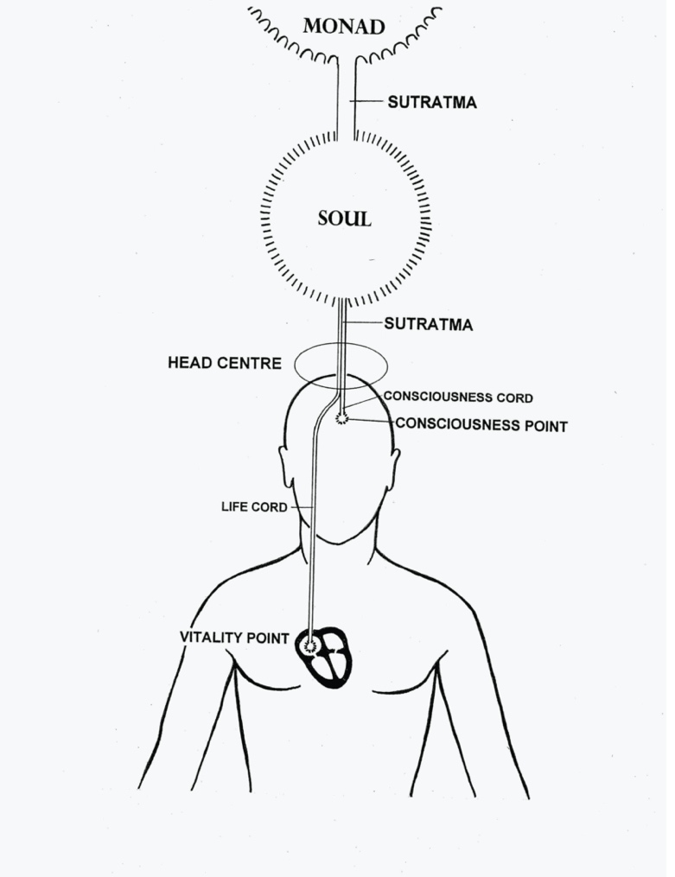

Let us examine these two essential aspects of the life stream:

The consciousness aspect of the sutratma which conveys the soul quality of intelligence and love-wisdom. It is seated in the brain near the pineal gland. It expresses itself through the nadis (slightly denser etheric channels underlying every nerve), thru the triple nervous system and finally, through the centres and their endocrine glands. The soul utilizes the consciousness aspect to make man an intelligent, rational entity – self-conscious and self-directing: He is aware, in ever growing degrees, depending on his evolutionary development, of the world in which he lives.

The life aspect of the sutratma, which conveys vitality from the soul, is anchored in the heart. From there it energizes and vitalizes the entire physical body via the physical permanent atom. It utilizes the blood stream as its agency of control and expression. It acts in concert with the consciousness aspect to control the endocrine glands. Thus the two aspects of the soul work together to make man a living, functioning entity under the influence of the soul.

As we have said, the soul imbues the personality with both life and consciousness through the sutratma. It would be logical to expect that the main purpose of practicing meditation would be to enhance the consciousness aspect – especially as meditation is an important factor in building the Antahkarana. However, I was surprised to find that the Tibetan puts it differently:

“Meditation is a technique of the mind which eventually creates correct alignment or establishes a direct channel not only between the Monad and the purified and controlled personality, but also between the 7 centres in the human etheric body. EH/ 620-1

He goes on to say: “You may find it astonishing that I place the results of meditation on the basis of physical – or rather etheric effects which you may regard as being the very lowest phase of such results. This is because you lay emphasis upon the satisfaction you acquire from mental contact with new worlds of phenomena and the consequent new concepts and ideas that impinge upon your mind. But the true results of meditation are correct alignment, right relationship, and clear channels for the seven energies in the micrcosmic system, thereby bringing about eventually a full expression of divinity.

All the 7 centres in the etheric vehicle of the Christ were rightly adjusted, correctly aligned, truly awakened and properly receptive of all the seven streams of energy coming from the seven planetary centres: these put Him en rapport and in full realized contact with the One in whom He lived and moved and had His being.

The physiological results of this perfect alignment was the appearance in the Christ of a perfect endocrine system. This produced a “perfect man” – physically perfect, emotionally stable and mentally controlled.

This brings us to LAW VII and to the section that relates directly to esoteric healing:

“When life or energy flows unimpeded and through right direction to its’ precipitation (the related gland), then the form responds and ill health disappears.”

“It is the major energy centres that literally hold the body together and where the two aspects of the soul come together to make the body function as a coherent, energized and active whole. “As we know, when death takes place, the consciousness cord ** withdraws from the head centre and the life cord withdraws from the heart centre. What is less known is how this dual withdrawal affects every centre within the body.”

“The consciousness cord, anchored in the head centre, has an essential involvement with the lotus of the head centre - called in oriental literature the “thousand petaled lotus”. The petals of this lotus have an important relationship and a definitely qualifying effect – both radiatory and magnetic – upon the petals in every one of the other major centres within the etheric body. The head centre maintains these petals in qualifying activity, and when this quality of conscious response is withdrawn from the head centre at death, an immediate effect is felt in all the petals of all the centres.”

In other words, the petals of the crown centre are in constant communication with all the petals of the other 6 major centres and maintain a coordinating influence upon the conscious qualities that they each express.

A similar process is true for life cord that is anchored in the right atrium of the heart. (I will refer to this point as the ‘vitality point’.) As long as the life cord is anchored in the ‘vitality point’ it brings life and vitality to all the centres of the body. This it does by means of threads of life which it sends out from its’ seat in the heart to the exact centre of the lotus of each of the other chakras. This central point in a chakra is sometimes referred to as the ‘jewel in the lotus’ though that phrase is more often applied to the monadic point at the heart of the egoic lotus on its own plane.

See 2nd Illustration: - showing relationship of Crown centre petals to a typical major centre.

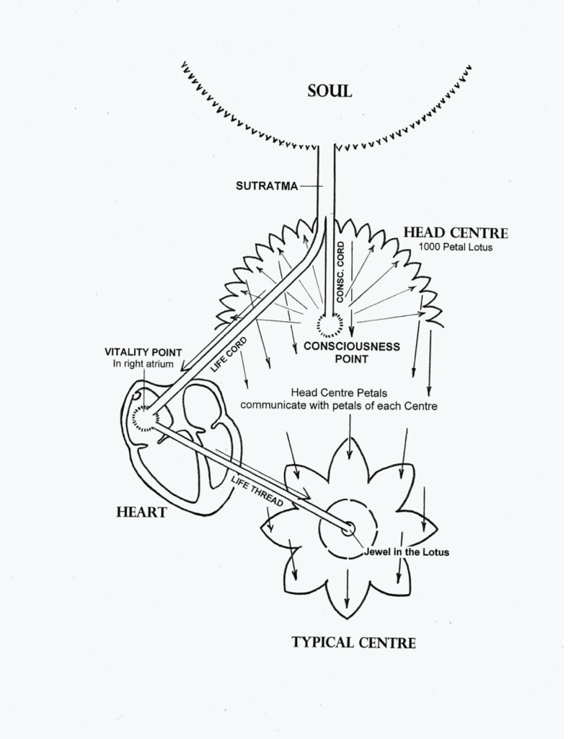

So the line of flow of the life aspect from the soul is via the sutratma into the head centre (along with the consciousness aspect) and then, by means of the life cord, to the vitality point in the heart and from there, by means of etheric threads, to the exact centre of each major centre.

At death the life cord is gathered up by the soul and is withdrawn from the heart into the head centre where it merges with the consciousness cord to return to the soul body. As it withdraws, it carries with it the life of each of the centres of the body. EH/622-23

As we know, each centre has a physical counterpart, an endocrine gland that acts in strict unison with it. Its purpose is to directly translate the energy of the centre into a bio-chemical activity in order to bring about effects upon the physical body. “The centres act upon their endocrine glands by directly impaction - by means of a stream of life energy emanating from the central point within the chakra.” This life force is focused in a point at the very heart of the lotus and, as it passes outward towards its’ gland, it takes on the quality of the energy for which that centre is responsible. EH/623

The life force itself, as supplied by the Sutratma, originates in the monad and is essentially unqualified. All energy emanation from the one source in this solar system is related to the second ray energy we call Love (i.e cosmic ray II) – and this energy is magnetic attraction. Before this ray of life enters into contact with the petals of each centre it possesses only this major innate quality of attractive energy.

The petals of the lotus and the energy field around the form of the lotus are qualified by one of the seven subsidiary rays. Therefore, as the life force passes thru the energy field of each centre it becomes ‘colored’ by the quality of the particular Ray of that centre. This energy, so qualified by one of the Rays, then plays upon the gland and affects its secretion activities. EH/618-19

See 3rd Illustration: - showing the life force passing thru a centre to its’ related gland.

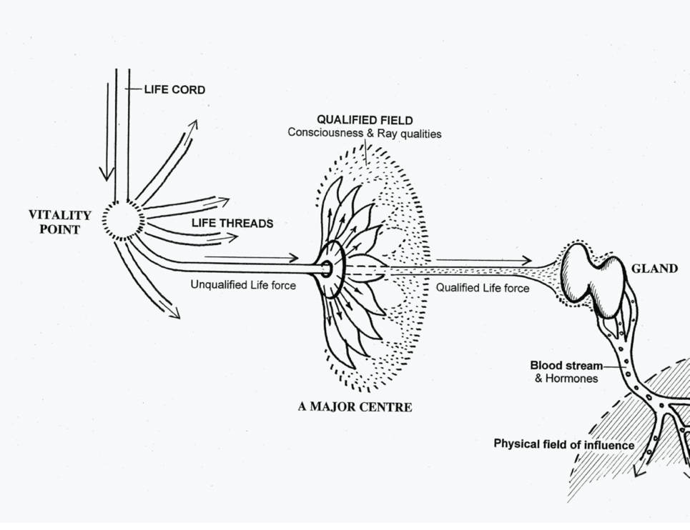

Here is a list of the centres and the Rays & qualities they each express: (see p.190 -T.W.M.)

Centre | Ray | Quality | Origin | Petals
Head Centre | 1st Ray | Divine Will | Monadic | 1000
Ajna Centre | 7th Ray | Organisation, Directing | Atmic | 2
Heart Centre | 2nd Ray | Love/Wisdom | Buddhic | 12
Throat Centre | 5nd Ray | Creativity | Mental | 16
Solar Plexus | 6th Ray | Emotion, Desire | Astral | 10
Sacral Centre | 3nd Ray | Procreation | Etheric | 6
Basic Centre | 4th Ray | Harmony thru conflict | Physical | 4

See 4th Illustration: - showing the seven major Centres and their various qualities. (page 190- TWM)

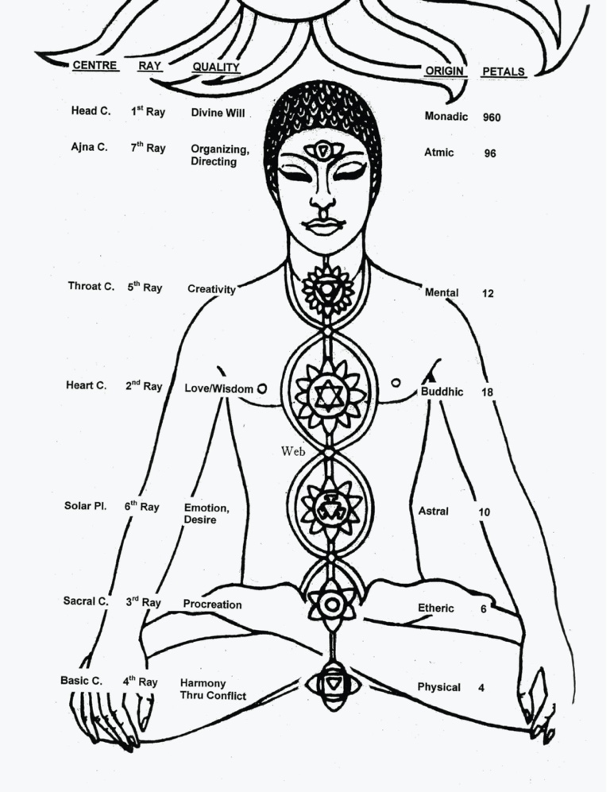

QUOTE: “It must ever be remembered that the centres are the major agency upon the physical plane thru which the soul works and expresses life and quality in accordance with the evolutionary stage of development. Over the span of a soul’s incarnational activities these centres are, in their turn, conditioned, qualified and controlled first by the emotional body, later by the mind and eventually by the soul. It is the goal of the evolutionary process to bring about this soul control of all the chakras.” EH/623

The glandulair system is an inevitable reflection of the state of the centres.
D.K. also tells us: “It can be said that the glands express fully the point in evolution of the person. During incarnation, energy or life flows thru the human mechanism unimpeded and under right direction in the case of the highly developed man, or impeded and imperfectly directed in the case of the average or undeveloped human being. It is thru this system of glandular control that the human form responds or does not respond to the surrounding world energies. The glands are direct precipitations of the seven types of energy flowing thru the seven etheric centres. Between them they control all areas of the body. In respect to one’s health, a person will be sick and ill or well and strong according to the state of the centres and their physical instruments – the glands. EH/623& 617

He then says: “I am anxious for this subject of the glands and their relation to the centres to be understood. The entire subject is closely related to the act of healing.” EH/618

As one would expect, the karmic process in any individual life must also work out thru the medium of the glands, since it is the glands that condition the reaction of the person to circumstance and events. The Lunar Lords work in cooperation with the law of Karma in constructing all our bodies.
This brings us to another important point and one that I was not fully aware of:
“Students should bear in mind that the primary effect of the activity of the glands & their secretions into the blood stream is psychological. A man is upon the physical plane emotionally and mentally what his glandular system makes him and, incidentally, what they make him physically – since that is frequently determined by his emotions and his psychological state of mind. But the state of the glands are, in their turn, determined by the state of the inner potent energy of his centres. “

Again I repeat this vital truth. For the world of causes is the etheric body with its 7 centres. It is for this reason that medical science will eventually find the truth that it is impossible to fundamentally change the personality and the physical equipment of man through the medical treatment of the glands themselves.” EH/625-626

“The healer therefore ignores the gland involved and deals directly with the centre which conditions the “point of friction” and controls the area under its influence. There are other minor centres and subsidiary glands in the body but the 7 major centres are the ones with which the healer works. These minor centres and glands are conditioned by the major centre that controls the area in which they are located. Again, it is the 7 major centres and their endocrine glands with their secretions which determine the psychological makeup of man and his state of health.” EH/625-626

(Note: This does not mean you should not work with the glands in the way that we teach it. But it does mean that your results will be limited if you do not effectively treat the Major Centre that conditions the gland.)

In this last statement he is indicating that working with the major Centres by occult methods can play an important role in helping individuals suffering with emotional or mental problems. I searched around for further information in his books to support this idea and found the following:

“Until the modern therapist recognizes the fact of the etheric body and works scientifically and intelligently with it and its major centres of force, their efforts will prove to be insufficient. Without understanding the role of the etheric body they have nothing that relates the emotional nature with the physical mechanism; this creates a gap in their thinking and in their therapeutic methods.”

Where a person’s consciousness is focused primarily on emotional or mental levels, the life stream cannot anchor as strongly into its seat in the heart. As a result only a part of the vital energy will find its way into the physical body through the centres while the greater part of it will be retained on the level where the consciousness is predominately functioning. In other words, until the major Centres of the etheric body are replenished with life energy and their glands are functioning normally, such an individual cannot become ‘balanced’ or cannot feel, think and act normally.

Returning to Law VII and its application, the Tibetan says:

“The concept in the mind of the healer should be to create a clear channel through which health-giving life may flow into the appropriate centre in the body of the patient and from there into the blood stream via the related gland. “The truth remain eternally right that the “blood is the life.” EH/626-627

And what about the problem of diseases? If we go back to the discussion of Law I we find the following:

”The healer seeks, by the power of his own soul, to stimulate the point of soul life in the etheric body of the patient in order that the life thread may carry a fuller supply of life to the heart. In this manner, the patient will be healed by the natural and normal way of fuller vitality, and so enabled to throw off the disease.” Eh/541

Elsewhere he says: The 2 major predisposing causes that give rise to all health problems in the physical organism are the understimulation or overstimulation of the major centres. There are three diseases inherent in the substance of the planet itself that create a predisposition within every human body: these are cancer, syphilis and tuberculosis.

“But it is the state of the centres that produces the underlying condition that permits the entrance of infections and germs that might not otherwise cause trouble. We might make the premise that those diseases that are not due to contagion or accidents are caused by the failure or limitation, the deficiency or excess of the endocrine system whose hormones affect every part of the physical organism via the blood stream. And it may therefore be truly posited that when the ductless glands are perfectly balanced and functioning correctly, there will be no diseased areas of the body.”

Here is another quote from LAW VII:

“Healers have to learn to work with the life principle and not with some vague energy which is set in motion by the potency of ‘right thought’ or the potency of ‘love’. This life principle is contacted and set in motion by the method of clearing certain etheric channels within the etheric body. This clearance is not brought about by affirming ‘divinity’ or by eliminating ‘error’ in thinking but by the much more down-to-earth method of directing streams of energy through certain centres to affect the glands in that area of the physical body where the disease or pain or distress is located. The energy that is poured into these centres is not mental energy but one of the seven forms of life energy.

He then says: Two great streams of energy permeate the entire complex of systems that make up the human personality: The consciousness stream and the life stream. The consciousness stream works thru the nervous system and the life stream works thru the blood stream. Then the Tibetan makes a very important distinction: “The healer does NOT work with the consciousness aspect. He works ENTIRELY with the LIFE aspect.”

This raises the question: “Why should we not work with the consciousness aspect?”
Since D.K. doesn’t give us any reason for making this statement I had to look elsewhere for possible answers. What I found may at least give us some clues:

“The other agent for the distribution of energy in the human mechanism is the nervous system. It acts as an interface or intermediary between the centres and their ductless glands. (i.e. It imbues the life stream with certain qualities.) Here, however, there are usually difficulties to be found. Often there is a lack of adequate flow of energy; or the energy being distributed by the nervous system to the body via the centres is unevenly distributed; some centres may receive too much while others receive inadequate amounts; some centres are still unawakened and therefore unreceptive while others are prematurely developed and transmit too much force to the areas they govern. In esoteric medicine it is the cerebral-spinal nervous system that conditions and governs the entire system, since it is primarily thru the cerebral-spinal nerves that the major centres work and affect the physical organism.”

Eventually, the nervous system will become responsive to the seven centres. But in no human being, except a Master, is the nervous system correctly responsive to the centres. There are two main reasons for this:

1. The Head Centre (1000 petal lotus) is not yet awakened, or only slowly being developed.
(remember - the Head Centre communicates with and maintains a coordinating influence over the consciousness aspect of all the other Centres.)

2. The flow of energy thru the head to the major centres on the spine is uneven, owing to the fact that the etheric webs between the centres permits as yet only a very little energy to flow thru to all the centres.

This may only be a partial answer, but we can see from this that the mechanisms of consciousness are very complex and involve many factors. Returning to Law VII, the Tibetan makes a final point about working with the life stream:

“The perfect healer (at present non existent) works thru the closed and sealed point within the central point or within the very heart of every centre. It is there that the POINT OF LIFE is to be found.

From THIS POINT within the centre, LIFE rays out into the PETALS of the LOTUS and the combination of the LIFE at the heart of the centre and the CONSCIOUSNESS inherent within the petals is the SOURCE of the living, breathing, sensitive human being – the spiritual man. This statement, although somewhat simplified, is nevertheless basically true, and upon this truth the healer can act.”

This gives us a clear picture of how the Life aspect and Consciousness aspect come together in the major Centres (along with the Ray qualities) to create the spiritual man on earth. Without the Life aspect enlivening the petals the consciousness aspect cannot function normally. There are a number of principles raised here I believe are important for our furthered understanding of esoteric healing. For myself, I have gained a new appreciation for the importance of working with the Centres and their glands after doing this research

Key points covered in this talk:
1. The Sutratma is the means by which life is able to manifest and the means by which vitality and communication can occur between Monad, Soul and its Human manifestation.
2. The Sutratma is composed of two energies that the soul embodies and transmits to its personality reflection; these are life and consciousness.
3. These two aspects come together in the major centres to make the body function as a coherent, active and intelligent whole.
- The healer does not work with the consciousness aspect. He works entirely with the life aspect.
- A person will be sick and ill or well and strong according to the state of his centres and their physical counterpart – the endocrine glands.
- Students should bear in mind that the primary effect of the glands and their secretions into the blood stream is psychological.
- The state of the glands are determined by the state of the etheric centres and so the healer ignores the gland and works directly with the centre that controls the gland and its area of influence.
- The perfect healer works through the closed and sealed point within the very heart of every centre – the jewel in the lotus. It is there that the point of life is to be found.

(Note: In working with the major centres it may be more effective to visualize them as ‘wheel-like flowers’ in the etheric spine and to focus our energy work into the very central point of the flower.)

