Journal 31 page 7-8

Mitakuye Oyasin
– All My Relations

by Maddy Harland

The words Mitakuye Oyasin come from the Native American Lakota Nation and mean all my relations. They are spoken during prayer and ceremony to invite and acknowledge all relatives to the moment.

The concept of Mitakuye Oyasin honours the sacredness of each person’s individual spiritual path and the sacredness of all life (human, animal, plant, mineral and spiritual) and creates an energy of awareness which strengthens not only the person who prays but the entire planet. It represents ‘all that needed to be said’. It is a prayer of respect, honour and love for all of humankind, and for the Earth. It says, “I wish goodness and peace for all. I would leave no one out. I pray for all”. It is a prayer that crosses the barriers of religion and can be prayed by one of any faith. It is a prayer that unites, instead of divides.

Relatives: To most of us today, relative means a blood relation or another human in the family lineage. We have not been taught that an entity, other than human, could be a relative. Yet we live in a world of consciousness. The consciousness of the mineral kingdom is very different to our human consciousness but it is still conscious. If we live and breath the idea that we are all interconnected in a conscious universe, the practice of Mitakuye Oyasin comes alive in an extraordinary way.

The contemplation of Mitakuye Oyasin can change our outlook on life forever. If we love and honour all of our relatives, we are loving and honouring most of what is on this earth. If we lived by this meaning of ‘relative’, what a different world we would be living in! We would not take anything for granted. We would not unconsciously treat things as purely material – rocks and plants to be collected, animals to be exploited, or food to be eaten without thought of its origin ... Mitakuye Oyasin puts us in direct relationship with every aspect of the world around us. It naturally creates a sense of gratitude, wonder, and
a desire to protect and conserve.

Kinship: When we live like this we begin to learn the truth and start to find kinship with all life. This truth includes the mineral (what Native Americans call the Stone People), plant, animal, human, and Devic kingdoms. This also includes the great powers of the Four Winds of Change, the Cloud Nations, the Thunder Beings, the Little People (fairies), the Great Angelic Devas, and the four elements, Air, Earth, Water and Fire.

This teaching is articulated by the Native Americans but is universal and held by many great religions and practices all over the world. Much of it is deeply embedded in what we learn and what we do as Esoteric Healers. We just may have to put to one side the judgemental habit of regarding a relation that vibrates at the slowest rate as low down in the Hierarchy. If we are all One, enfolded in Divine consciousness, then there is only One Being, manifesting the many faces of God.

I have found the practice of Mitakuye Oyasin transformative as it reconnects us deeply with all life on our planet. When we become one with our relations, it becomes difficult to ignore their sentience and messages. This doesn’t mean we don’t use stones to build, eat plants and animals, or clear land for agriculture and settlements, but it does mean we begin to ask before we act and respect the answers that come back to us. We learn to slow down and listen and we naturally become more interested and focused on cohabiting and co-operating rather than the mantra of materialistic acquisition or waging dominion over other life.

Joy: Mitakuye Oyasin is also joyful. I believe that it is a spiritual teaching that brings fully alive the practice of conservation, permaculture and regenerative agriculture.

Ho!


The Journal of the INEH 7

AHO MITAKUYE OYASIN ... ALL MY RELATIONS
The Prayer From the Traditional Lakota Sioux

I honour you in this circle of life with me today. I am grateful for this opportunity to acknowledge you in this prayer ...

To the Creator, for the ultimate gift of life, I thank you.

To the mineral nation that has built and maintained my bones and all foundations of life experience, I thank you.

To the plant nation that sustains my organs and body and gives me healing herbs for sickness, I thank you.

To the animal nation that feeds me from your own flesh and offers your loyal companionship in this walk of life, I thank you.

To the human nation that shares my path as a soul upon the sacred wheel of Earthly life, I thank you.
To the Spirit nation that guides me invisibly through the ups and downs of life and for carrying the torch of light through the Ages, I thank you.

To the Four Winds of Change and Growth, I thank you.

You are all my relations, my relatives, without whom I would not live.

We are in the circle of life together, co-existing, co- dependent, co-creating our destiny. One, not more important than the other. One nation evolving from the other and yet each dependent upon the one above and the one below. All of us a part of the Great Mystery.

Thank you for this Life.

Practical

- Centre, Align, Attune, Allow

“To the Creator, for the ultimate gift of life, I thank you.”

Ajna + 5 major chakras Balance to Alta Major

- Basic centre + both adrenal minors Basic + long bones
Basic + skeletal structure (hold awareness of this wonderful living being)

“To the mineral nation that has built and maintained these bones and all foundations of life experience, I thank you.”

- Solar plexus + spleen minor + spleen organ

“To the plant nation that sustains my organs and body and gives me healing herbs for sickness, I thank you.”

- Heart + thymus + heart organ

“To the animal nation that feeds us from your own flesh and offers your loyal companionship in this walk of life, I thank you.”

(Even if you are a vegan, you rely on insect pollination and the healthy balance of species diversity to grow plants.)
- Throat centre + thyroid gland (2) Throat centre + parathyroid glands (4)
Upper Triangle of Force: Contains energy, organises, harmonises and co-ordinates this cavity.
Throat + minor below
Minor below throat + 2 breast minors

“To the human nation that shares our path as a soul upon the sacred wheel of Earthly life, I thank you.”

- Head Triangle
Crown + Ajna + Alta Major

“To the Spirit nation that guides us invisibly through the ups and downs of life and for carrying the torch of light through the Ages, I thank you.”

- Grounding triangles.
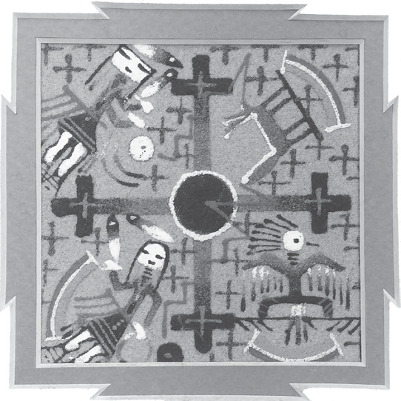

8 The Journal of the INEH

